

DC 12v Battery Low Voltage Auto Cut off Switch Controller Protection Module
2.5 out of 5 stars8 product ratings
About this
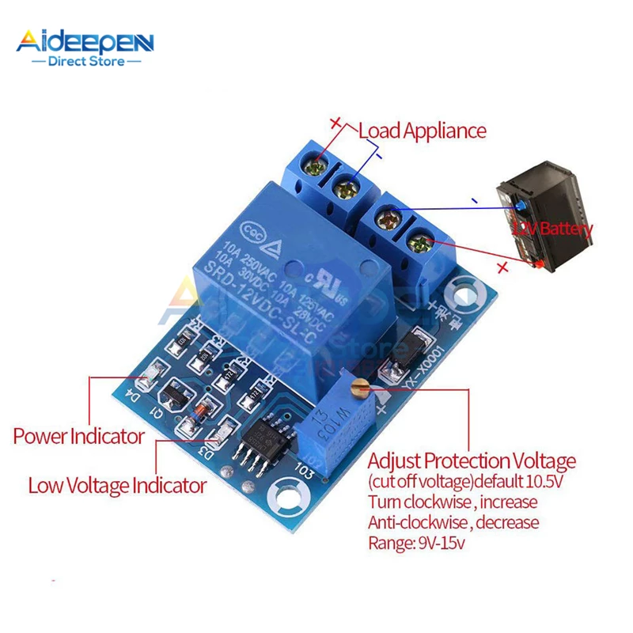

About this product

Product Identifiers
- GTIN
0826963827061
- UPC
0826963827061
- eBay Product ID (ePID)
25012856089

Product Key Features
- Nominal Voltage Rating (DC)
12 V
- Protection Properties
Low Voltage Protection
- Nominal Current Rating
10 A
- Current Conversion
DC to DC
- Type
Forward Converter
- Output Voltage Rating (DC)
10 V
- Inrush Current Rating
10 A

Dimensions
- Item Height
40*29*19mm/1.57*1.14*0.74'

Most relevant reviews
See all 6 reviews
- 1 out of 5 stars
by psha5970Mar 12, 2018

Does not perform as expected. I do not recommend this product.
Poor technical design. Does not perform as expected. When battery reaches cut-off voltage (i.e. 10.5VDC), the relay chatters and does not cut-off the battery. The relay "chatters" as in it is switching at high speed on-off-on-off. The battery is not isolated with it reaches the desired drop off voltage. The addition of a 25Volt (1000uf) Capacitor, as suggested in the write-up, does not achieve any difference in operation. I do not recommend this product. Do not buy.
Verified purchase: Yes | Condition: New
- 1 out of 5 stars
by jonnrantaJul 13, 2019

Do not work
I bought couple of these for my 12vdc portable cool box. I installed it accordingly ,but it on cut the voltage about 3-4volts and the cool box still keep running, circuit itself kept making whining nois when voltage dropped below 10,5vdc. Then i tried the other circuit as well but samething. So these circuits dont do their job at all. Waste of Time and monet. :( PS.im a electrician.
Verified purchase: Yes | Condition: New
- 3 out of 5 stars
by condewOct 05, 2018

Against expectations, relay activates below set voltage.
Draws 33mA when below set voltage, 6mA when above. It would be better to activate the relay and draw more power when above the set voltage. When the battery is already below the level of charge where you want protection to engage, a module like this would ideally draw less current, not more. Still useful where battery is fairly large and won't be left discharged for a long time.
Verified purchase: Yes | Condition: New
- 1 out of 5 stars
by wirewigglerJun 16, 2019

Product never arrived
Been a couple of months product never arrived. Guess I will have to quit buying products from China, they just blow you off when you complain about product not arriving . Guess I will see if PayPal will make it right.
Verified purchase: Yes | Condition: New
- 5 out of 5 stars
by divnicApr 18, 2018

OK
Verified purchase: Yes | Condition: New

